ALL ABOUT DB

--1—

use master

go

CREATE DATABASE [eDateA]

CONTAINMENT = NONE

ON PRIMARY

( NAME = N'eDateA_master', FILENAME = N'C:\MYData\eDateA_master.mdf' ,

SIZE = 3072KB , FILEGROWTH = 2048KB ),

FILEGROUP [Archive]

( NAME = N'eDateA_Archive', FILENAME = N'C:\MYData\eDateA_Archive.ndf' ,

SIZE = 10240KB , FILEGROWTH = 0),

FILEGROUP [Data]

( NAME = N'eDateA_Data1', FILENAME = N'C:\MYData\eDateA_Data1.ndf' ,

SIZE = 5120KB , FILEGROWTH = 10%),

( NAME = N'eDateA_DAta2', FILENAME = N'C:\MYData\eDateA_DAta2.ndf' ,

SIZE = 5120KB , FILEGROWTH = 10%)

LOG ON

( NAME = N'eDateA_log', FILENAME = N'C:\MYData\eDateA_log.ldf' ,

SIZE = 5120KB , FILEGROWTH = 10%)

GO

ALTER DATABASE [eDateA] SET COMPATIBILITY_LEVEL = 130

GO

ALTER DATABASE [eDateA] SET ANSI_NULL_DEFAULT OFF

GO

ALTER DATABASE [eDateA] SET ANSI_NULLS OFF

GO

ALTER DATABASE [eDateA] SET ANSI_PADDING OFF

GO

ALTER DATABASE [eDateA] SET ANSI_WARNINGS OFF

GO

ALTER DATABASE [eDateA] SET ARITHABORT OFF

GO

ALTER DATABASE [eDateA] SET AUTO_CLOSE OFF

GO

ALTER DATABASE [eDateA] SET AUTO_SHRINK OFF

GO

ALTER DATABASE [eDateA] SET AUTO_CREATE_STATISTICS ON(INCREMENTAL = OFF)

GO

ALTER DATABASE [eDateA] SET AUTO_UPDATE_STATISTICS ON

GO

ALTER DATABASE [eDateA] SET CURSOR_CLOSE_ON_COMMIT OFF

GO

ALTER DATABASE [eDateA] SET CURSOR_DEFAULT GLOBAL

GO

ALTER DATABASE [eDateA] SET CONCAT_NULL_YIELDS_NULL OFF

GO

ALTER DATABASE [eDateA] SET NUMERIC_ROUNDABORT OFF

GO

ALTER DATABASE [eDateA] SET QUOTED_IDENTIFIER OFF

GO

ALTER DATABASE [eDateA] SET RECURSIVE_TRIGGERS OFF

GO

ALTER DATABASE [eDateA] SET DISABLE_BROKER

GO

ALTER DATABASE [eDateA] SET AUTO_UPDATE_STATISTICS_ASYNC OFF

GO

ALTER DATABASE [eDateA] SET DATE_CORRELATION_OPTIMIZATION OFF

GO

ALTER DATABASE [eDateA] SET PARAMETERIZATION SIMPLE

GO

ALTER DATABASE [eDateA] SET READ_COMMITTED_SNAPSHOT OFF

GO

ALTER DATABASE [eDateA] SET READ_WRITE

GO

ALTER DATABASE [eDateA] SET RECOVERY FULL

GO

ALTER DATABASE [eDateA] SET MULTI_USER

GO

ALTER DATABASE [eDateA] SET PAGE_VERIFY CHECKSUM

GO

ALTER DATABASE [eDateA] SET TARGET_RECOVERY_TIME = 60 SECONDS

GO

ALTER DATABASE [eDateA] SET DELAYED_DURABILITY = DISABLED

GO

USE [eDateA]

GO

ALTER DATABASE SCOPED CONFIGURATION SET MAXDOP = 0;

GO

ALTER DATABASE SCOPED CONFIGURATION FOR SECONDARY SET MAXDOP = PRIMARY;

GO

ALTER DATABASE SCOPED CONFIGURATION SET LEGACY_CARDINALITY_ESTIMATION = OFF;

GO

ALTER DATABASE SCOPED CONFIGURATION FOR SECONDARY SET LEGACY_CARDINALITY_ESTIMATION = PRIMARY;

GO

ALTER DATABASE SCOPED CONFIGURATION SET PARAMETER_SNIFFING = ON;

GO

ALTER DATABASE SCOPED CONFIGURATION FOR SECONDARY SET PARAMETER_SNIFFING = PRIMARY;

GO

ALTER DATABASE SCOPED CONFIGURATION SET QUERY_OPTIMIZER_HOTFIXES = OFF;

GO

ALTER DATABASE SCOPED CONFIGURATION FOR SECONDARY SET QUERY_OPTIMIZER_HOTFIXES = PRIMARY;

GO

USE [eDateA]

GO

IF NOT EXISTS (SELECT name FROM sys.filegroups WHERE is_default=1 AND name = N'Data') ALTER DATABASE [eDateA] MODIFY FILEGROUP [Data] DEFAULT

GO

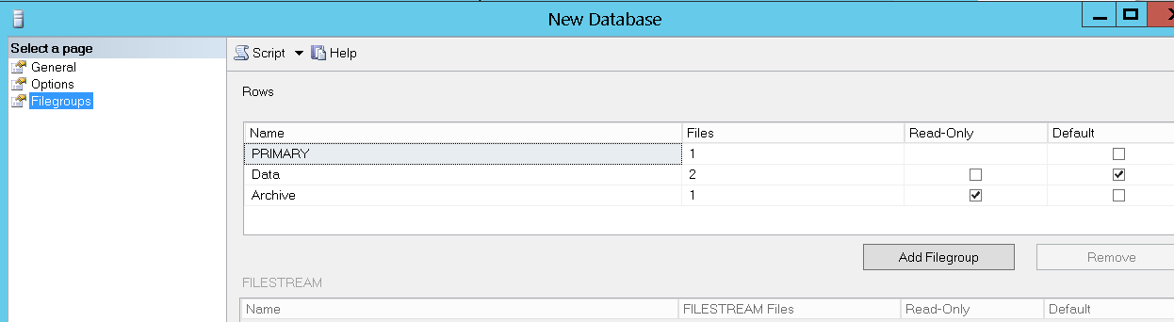

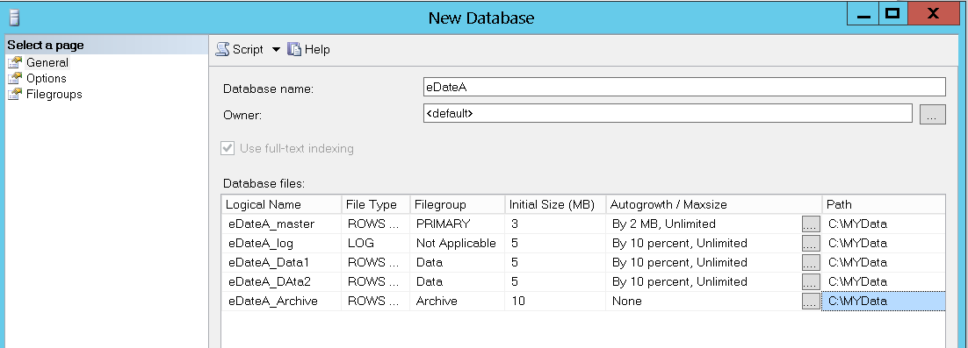

--3—

select db.name, db.database_id, db.compatibility_level,

mf.name, mf.physical_name, mf.type , mf.size

from sys.databases db , sys.master_files mf

where db.database_id = mf.database_id

and db.database_id = DB_ID('edateA')

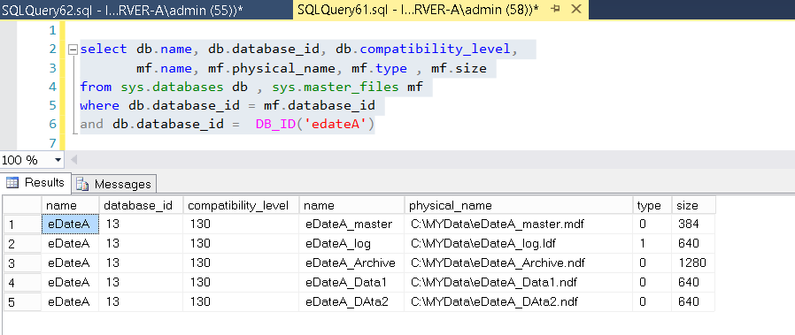

--4—-

USE [eDateA]

GO

IF NOT EXISTS (SELECT name FROM sys.filegroups WHERE is_default=1 AND name = N'PRIMARY') ALTER DATABASE [eDateA] MODIFY FILEGROUP [PRIMARY] DEFAULT

GO

USE [eDateA]

GO

ALTER DATABASE [eDateA] REMOVE FILE [eDateA_Data1]

GO

ALTER DATABASE [eDateA] REMOVE FILE [eDateA_DAta2]

GO

ALTER DATABASE [eDateA] REMOVE FILEGROUP [Data]

GO

USE [eDateA]

GO

ALTER DATABASE [eDateA] REMOVE FILE [eDateA_Archive]

GO

ALTER DATABASE [eDateA] REMOVE FILEGROUP [Archive]

GO

-------***-------

USE [eDateA]

GO

ALTER DATABASE [eDateA] ADD FILEGROUP [MyNewFG]

GO

ALTER DATABASE [eDateA] ADD FILE ( NAME = N'eDateA_New1',

FILENAME = N'C:\MYNewData\eDateA_New1.ndf' , SIZE = 5120KB , FILEGROWTH = 65536KB ) TO FILEGROUP [MyNewFG]

GO

ALTER DATABASE [eDateA] ADD FILE ( NAME = N'eDateA_New2',

FILENAME = N'C:\MYNewData\eDateA_New2.ndf' , SIZE = 5120KB , FILEGROWTH = 65536KB ) TO FILEGROUP [MyNewFG]

GO

ALTER DATABASE [eDateA] MODIFY FILE ( NAME = N'eDateA_master', SIZE = 5120KB , FILEGROWTH = 10240KB )

GO

ALTER DATABASE [eDateA] ADD FILE ( NAME = N'eDateA_Primery',

FILENAME = N'C:\MYData\eDateA_Primery.ndf' , SIZE = 5120KB , FILEGROWTH = 65536KB ) TO FILEGROUP [PRIMARY]

GO

ALTER DATABASE [eDateA] MODIFY FILE ( NAME = N'eDateA_log', MAXSIZE = UNLIMITED, FILEGROWTH = 65536KB )

GO

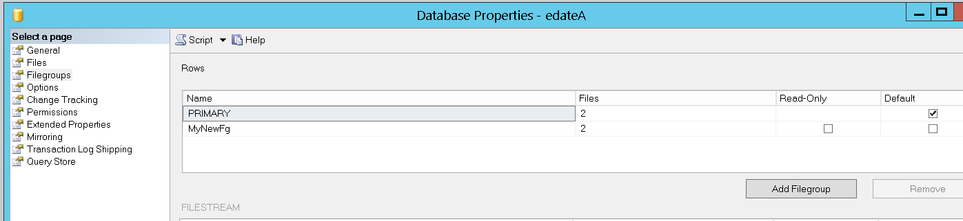

--5—

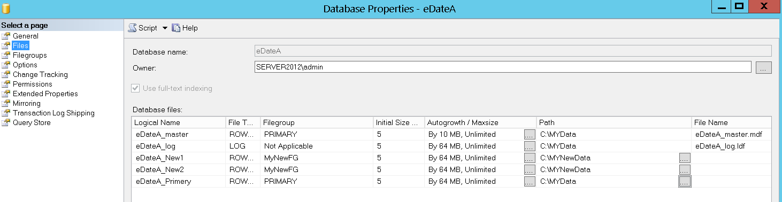

--6—

CREATE TABLE [dbo].[MyNGFriends](

[Id] [int] IDENTITY(1,1) NOT NULL,

[Name] [nvarchar](100) NULL,

[Phone] [nvarchar](20) NULL,

[Birthdate] [date] NULL,

CONSTRAINT [PK_MyNGFriends] PRIMARY KEY CLUSTERED

(

[Id] ASC

)WITH (PAD_INDEX = OFF,

STATISTICS_NORECOMPUTE = OFF,

IGNORE_DUP_KEY = OFF,

ALLOW_ROW_LOCKS = ON,

ALLOW_PAGE_LOCKS = ON) ON [MyNewFg]

) ON [MyNewFg]

-------***-------

SET IDENTITY_INSERT MyNGFriends ON

INSERT INTO MyNGFriends (id, Name, Phone, Birthdate)

select ss.Id, ss.FirstName,ss.PhoneNumber, ss.BirthDate

from [eDate].Operation.Members ss

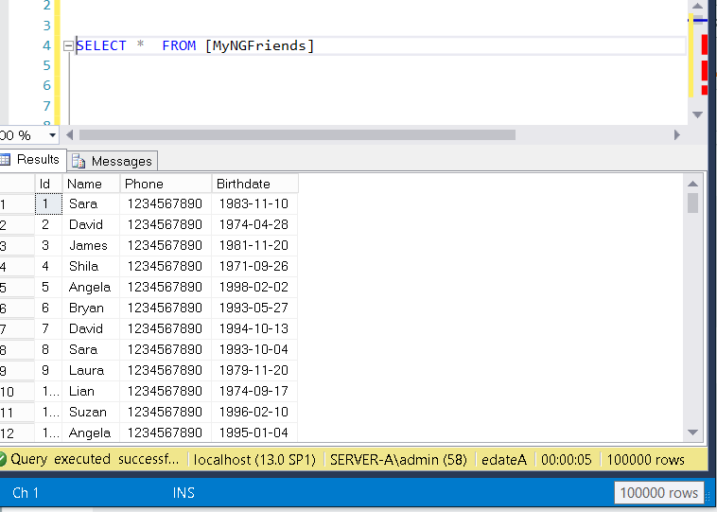

-------***-------

* גדל רק קובץ LOG

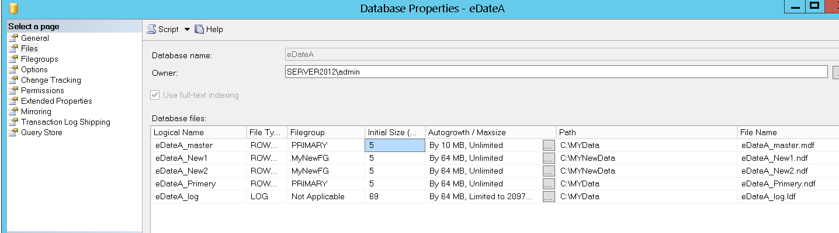

--7—

USE [master]

GO

DROP DATABASE [edateA]

GO

-------***-------

CREATE DATABASE [eDateA]

CONTAINMENT = NONE

ON PRIMARY

( NAME = N'eDateA', FILENAME = N'C:\MYNewData\eDateA.mdf' , SIZE = 10240KB , FILEGROWTH = 65536KB ),

FILEGROUP [NewGroup]

( NAME = N'eDateA_New', FILENAME = N'C:\MYNewData\eDateA_New.ndf' , SIZE = 10240KB , FILEGROWTH = 65536KB )

LOG ON

( NAME = N'eDateA_log', FILENAME = N'C:\MYNewData\eDateA_log.ldf' , SIZE = 10240KB , FILEGROWTH = 65536KB )

GO

-------***-------

USE [edateA]

GO

SELECT * INTO MyNGFriends from [eDate].Operation.Members